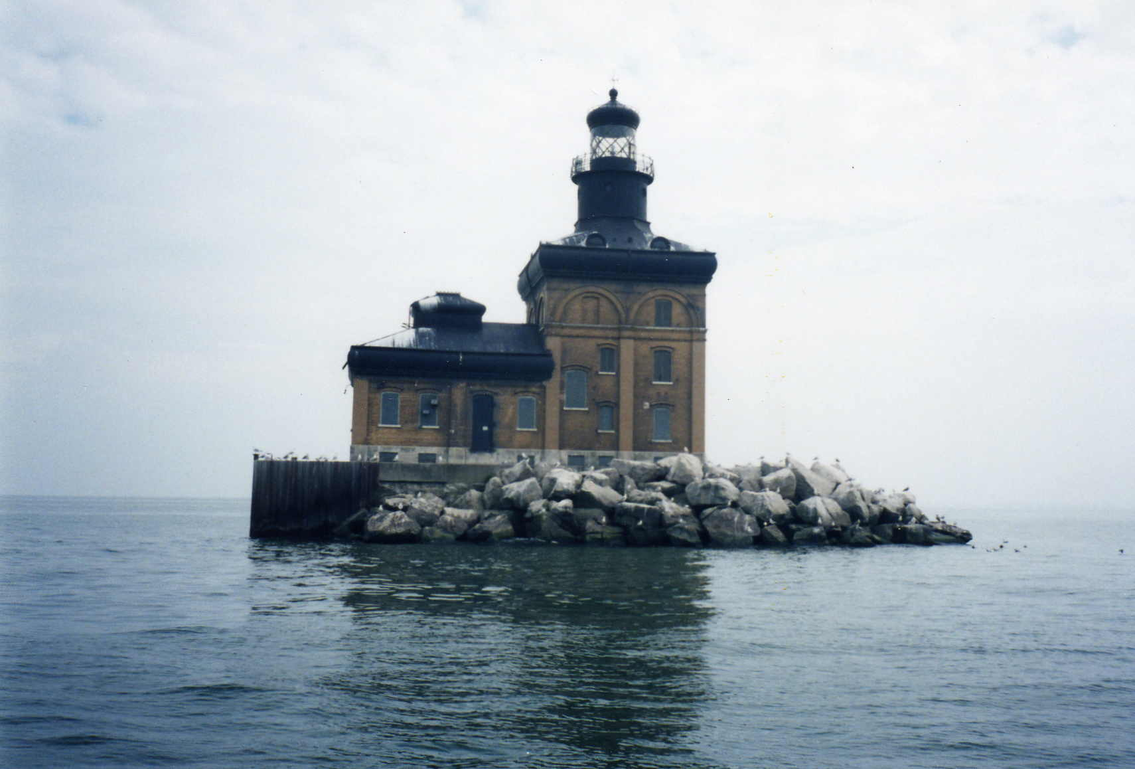TOLEDO HARBOR LIGHTHOUSE SOCIETY

MEMBERSHIP APPLICATION

JOIN US
Visit the web site at toledoharborlighthouse.org

The Toledo Harbor Light Society was organized in 2003 as all volunteer whose objective is to promote, maintain and restore the lighthouse. We have nearly 600 members who are helping this effort. We hope that you will join us:
- To preserve the Toledo Harbor Light
- To document the history of the Toledo Harbor Light including construction prints, diagrams, lighthouse keepers, and other lighthouse information.
- To educate and celebrate the existence of the Toledo Harbor Light at the mouth of the Western basin of Lake Erie and Maumee Bay, and the entrance to the Toledo shipping channel.
- To fund the $1.5 million three phase restoration project. Phase One funding has a grant for $500,000 and we have ‘My Lighthouse Window’ capital campaign to meet the required $138,000 match.
- To provide public access once restored by manning the lighthouse in season with 4 people who will stay at the lighthouse for 3 days to a week.
- To cooperate with all units of government and other organization for the preservation and restoration of the Toledo Harbor Light.
- To celebrate the lighthouse and fund raise at an annual Toledo Lighthouse Festival held the weekend after the 4th of July at Maumee Bay State Park.
Your membership, contributions and help will ensure the success. As a member you are invited to attend meetings on the last Thursday of the month at 7:00 p.m. at the Maumee Bay Resort. Please join the team to preserve the light. Thank you for your support. Updated information is on the web site – toledoharborlighthouse.org. Questions on membership should be sent to Dan Hall at dhalloh@comcast.net.

To join, fill in the following (print or type) and mail it with your membership fee (and/ or donation) payable to TOLEDO HARBOR LIGHT SOCIETY, non-profit 501 (C) (3).
Toledo Harbor Lighthouse Society C/O Maumee Bay Resort 1750 Park Rd #2 Oregon, Ohio 43616

Name:
Address:
City, State, Zip:
Home Phone: Work Phone:
Fax: E-Mail:

Please enroll me in the following membership category (check one):
__ Individual $20 (Basic membership)
__ Family $35
__ Corporate member __ $250 __$500 __$1,000
Initial membership term runs through December 31, 2004.

ENDOWMENT: I would like to make a donation in the amount of $ ___________ in honor/memory of ____________________________________________________________________________________________

My area(s) of interest: ___ Restoration ___ Fundraising ___ Marketing
_____ Help at Festival ____________Skill to Help ____________Other(Boat)

Signature: _____________________________________ Date: ___________________

